|  |
| --- |
| EPAM Systems, RD Dep. |
| MTN.BI.07 Star Schema Basics |

|  |  |  |  |  |  |
| --- | --- | --- | --- | --- | --- |
| REVISION HISTORY | | | | | |
| Ver. | Description of Change | Author | Date | Approved | |
| Name | Effective Date |
| 1.0 | Initial status | [Kiryl Bucha](mailto:Kiryl_Bucha@epam.com) | 12-JAN-2012 |  |  |
| 2.0 | Updated in accordance with renewed content | [Elias Nema](mailto:Elias_Nema@epam.com) | 20-JAN-2014 |  |  |

Contents

1. Data Modelling Task 3

2. Analytical task 3

3. Results 4

# Data Modelling Task

Here is a typical business model:

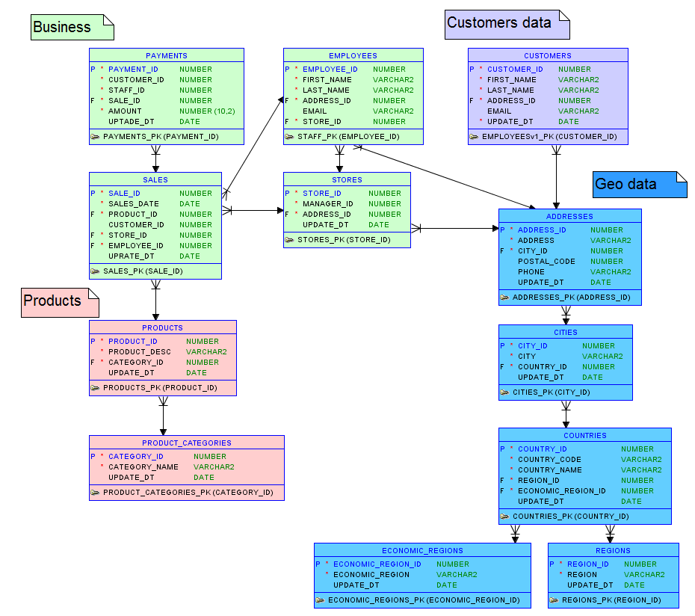

It is in close to 3rd normal form and we can logically divide it in business categories (such as Business, Customer data and Product data).

The task is to build star schema from this model and describe steps of applying 4-step process and denormalizing the model.

The second model that is need to be built is snowflake schema (Hint: to get snowflake apply some normalization rules to Star schema).

# Analytical task

The main analytical task is to create model of active worldwide business and fill business veins with blood of data after that.

For the next lessons you’ll be creating document describing your chosen business and creating plan of implementing data warehousing for this business.

Your document need to contain next chapters:

1. Overview and some short description of your business. Give some paragraph about purpose and processes in business.
2. The problems that business is facing because of poor data management.
3. What benefit business will get from implementing data warehouse?

# Results

Result of this lab work should be:

* Image of the star schema model.
* Image of the snowflake schema model.
* Document about chosen business.